**Simulink Training**

**LAB # 02**



**FALL 2021**

**CSE301L-Digital Signal Processing**

Submitted by: **Ashfaq Ahmad**

Registration No: **19PWCSE1795**

Class Section: **B**

“On my honor, as student of University of Engineering and Technology, I have neither given nor received unauthorized assistance on this academic work.”

Student Signature: ______________

Submitted to:

**Prof. Ihsan Ul Haq**

December 02, 2021

**Department of Computer Systems Engineering**

**University of Engineering and Technology, Peshawar**

|  |  |  |  |  |
| --- | --- | --- | --- | --- |
| **Demonstration of Concepts** | **Poor (Does not meet expectation (1))**  The student failed to demonstrate a clear understanding of the assignment concepts | **Fair (Meet Expectation (2-3))**  The student demonstrated a clear understanding of some of the assignment concepts | **Good (Exceeds Expectation (4-5)**  The student demonstrated a clear understanding of the assignment concepts | **Score**  **30%** |
| **Accuracy** | The student completed ( <50%) tasks and provided MATLAB code and/or Simulink models with errors. Outputs shown are not correct in form of graphs (no labels) and/or tables along with incorrect analysis or remarks. | The student completed partial tasks (50% - <90%) with accurate MATLAB code and/or Simulink models. Correct outputs are shown in form of graphs (without labels) and/or tables along with correct analysis or remarks. | The student completed all required tasks (90%-100%) with accurate MATLAB code and/or Simulink models. Correct outputs are shown in form of labeled graphs and/or tables along with correct analysis or remarks. | **30%** |
| **Following Directions** | The student clearly failed to follow the verbal and written instructions to successfully complete the lab | The student failed to follow the some of the verbal and written instructions to successfully complete all requirements of the lab | The student followed the verbal and written instructions to successfully complete requirements of the lab | **20%** |
| **Time Utilization** | The student failed to complete even part of the lab in the allotted amount of time | The student failed to complete the entire lab in the allotted amount of time | The student completed the lab in its entirety in the allotted amount of time | **20%** |

**Objectives**

1. **Course Overview**
   1. Familiarize yourself with the course.

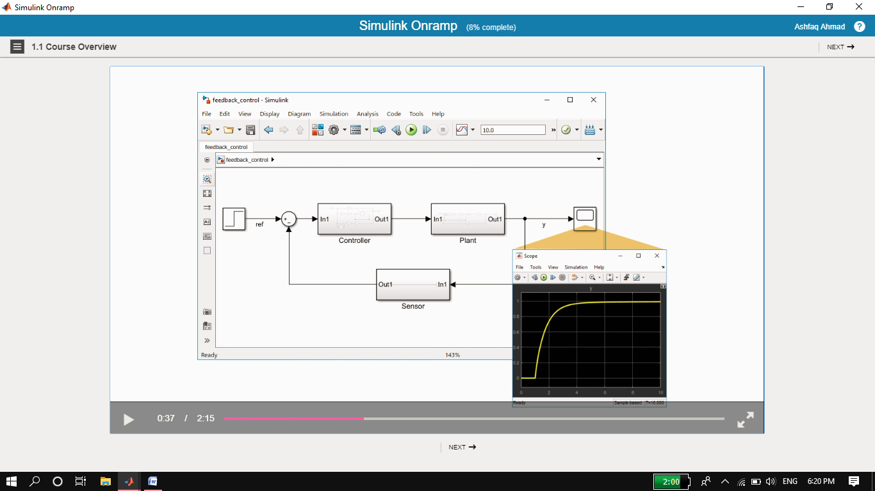

**Remark:**

We can model any system using Simulink.

1. **Simulink Graphic Environment**
   1. Learn about Simulink blocks and signals.

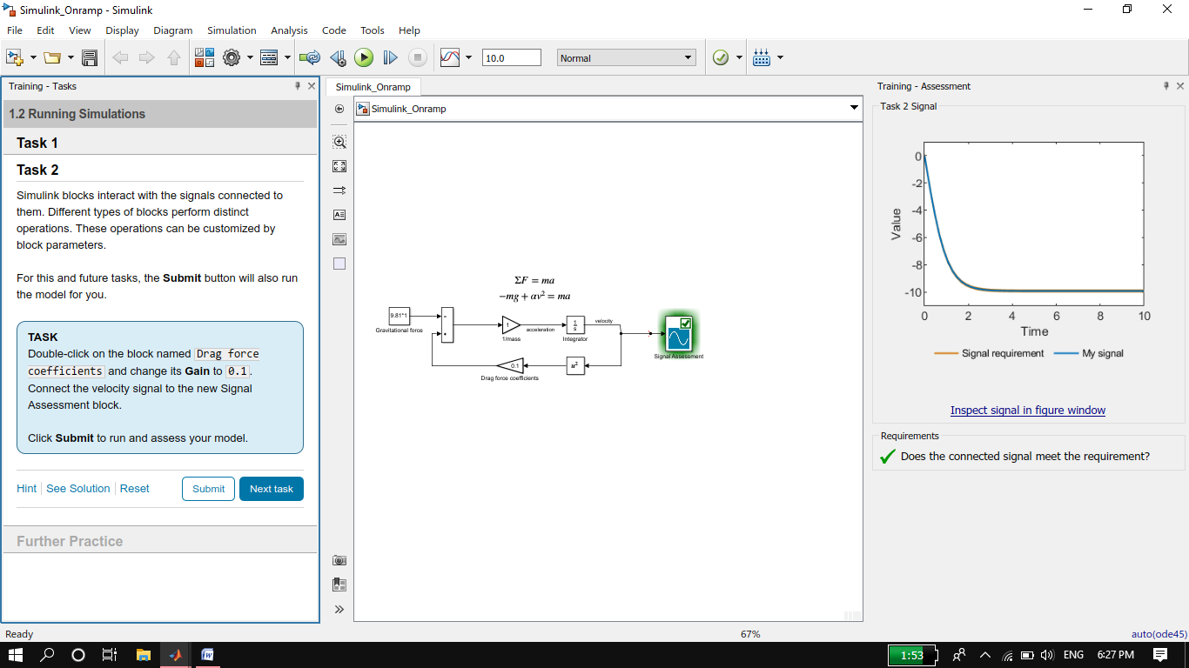

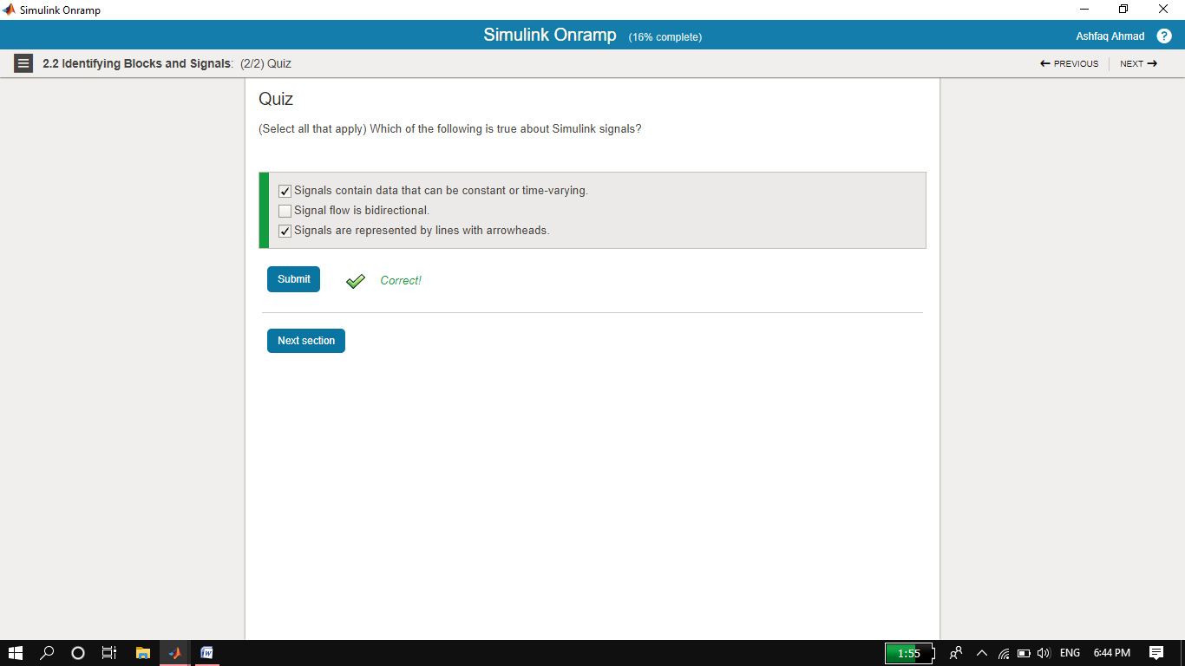

1. **Inspecting Signals**
   1. Visualize signal values during simulation.

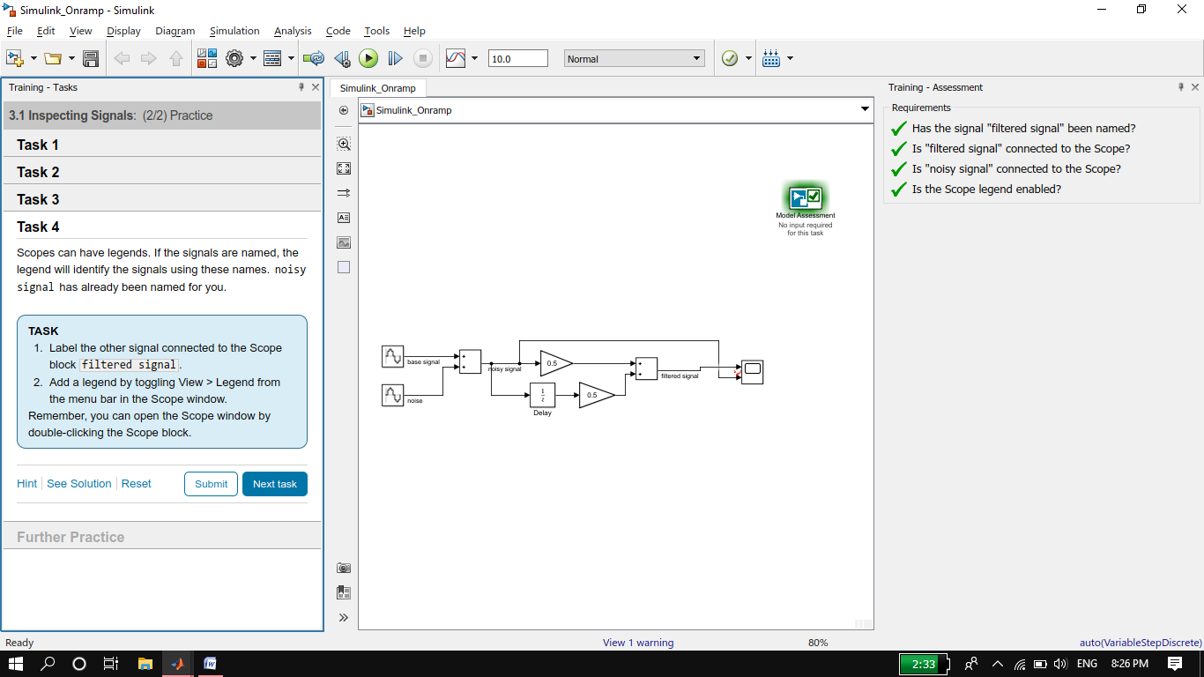

1. **Use Basic Algorithms**
   1. Use math and logic operators to write algorithms.

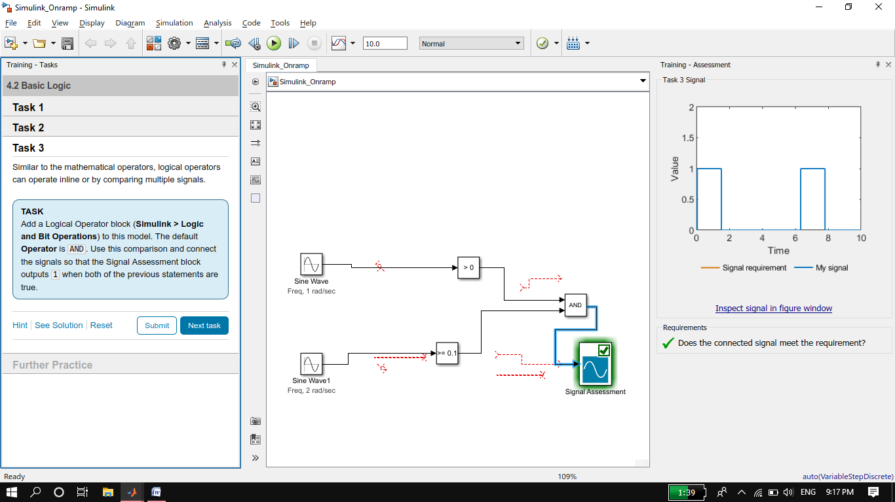

1. **Obtaining Help**
   1. Access documentation from Simulink.

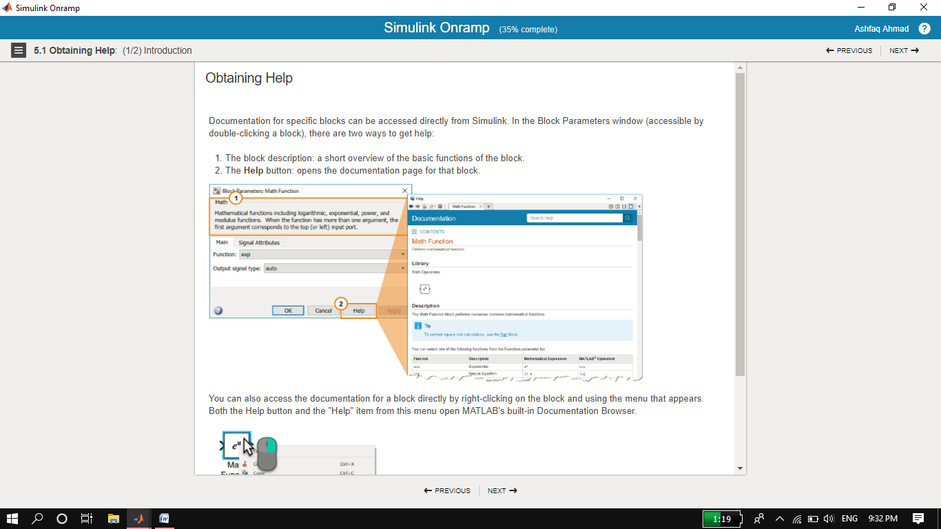

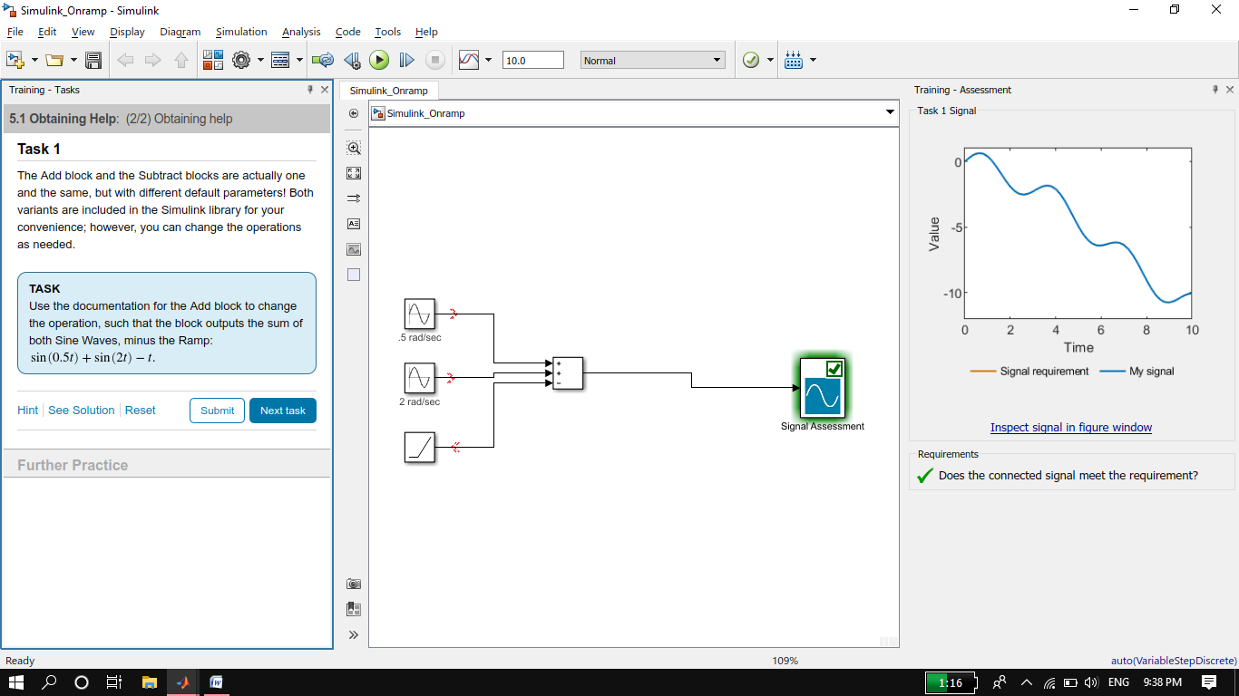

1. **Project- Automotive Performance Modes**
   1. Practice working with math and logic operators.

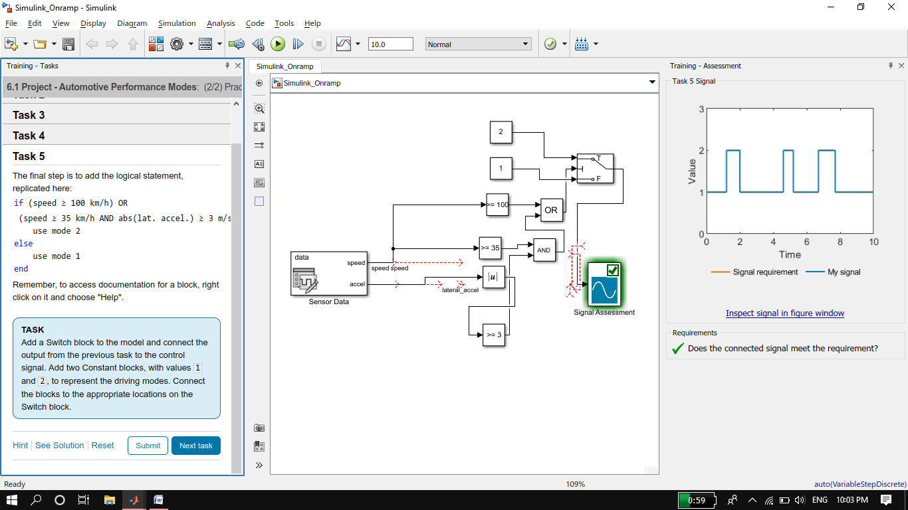

1. **Simulink and Matlab**
   1. Use MATLAB variables and functions in Simulink.

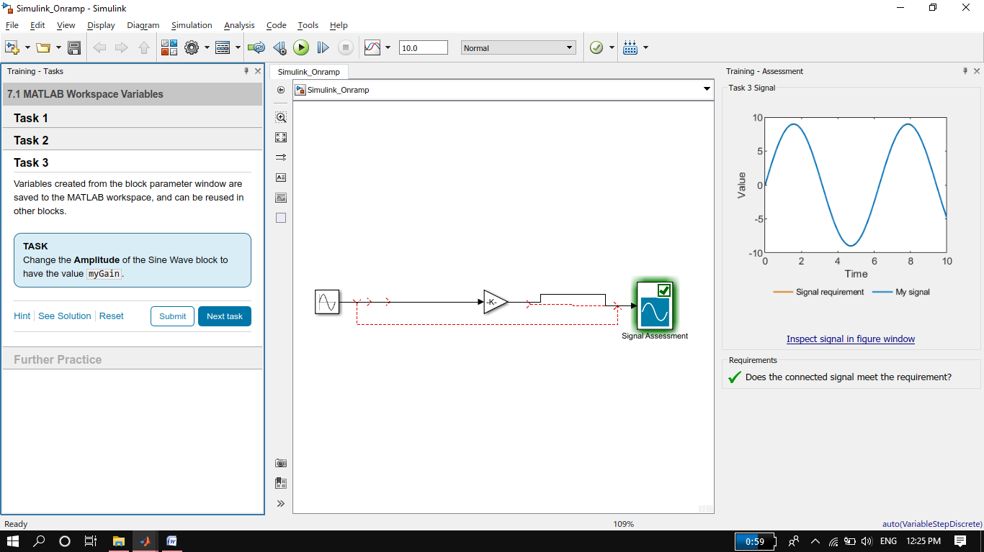

1. **Dynamic systems in Simulink**
   1. Review dynamic systems and learn how they relate to Simulink.

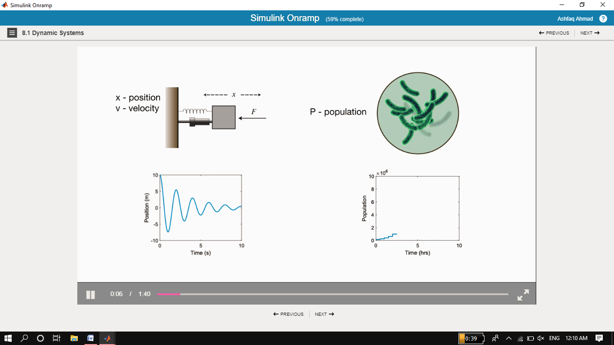

1. **Discrete Systems**
   1. Model discrete-time systems.

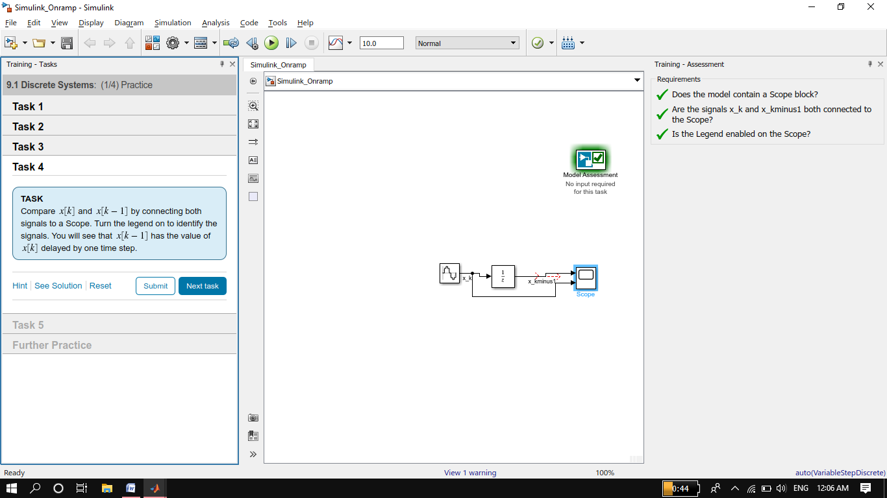

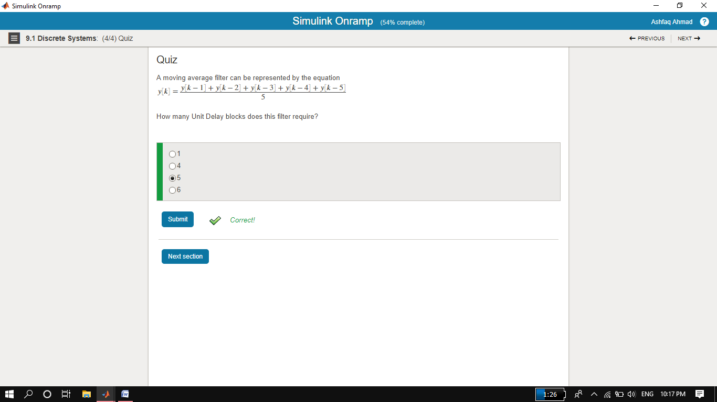

1. **Continuous Systems**
   1. Model continuous-time systems

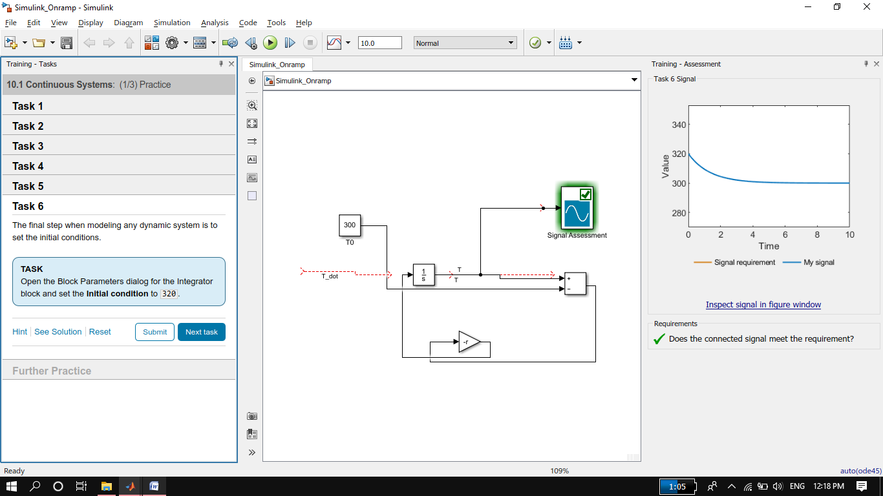

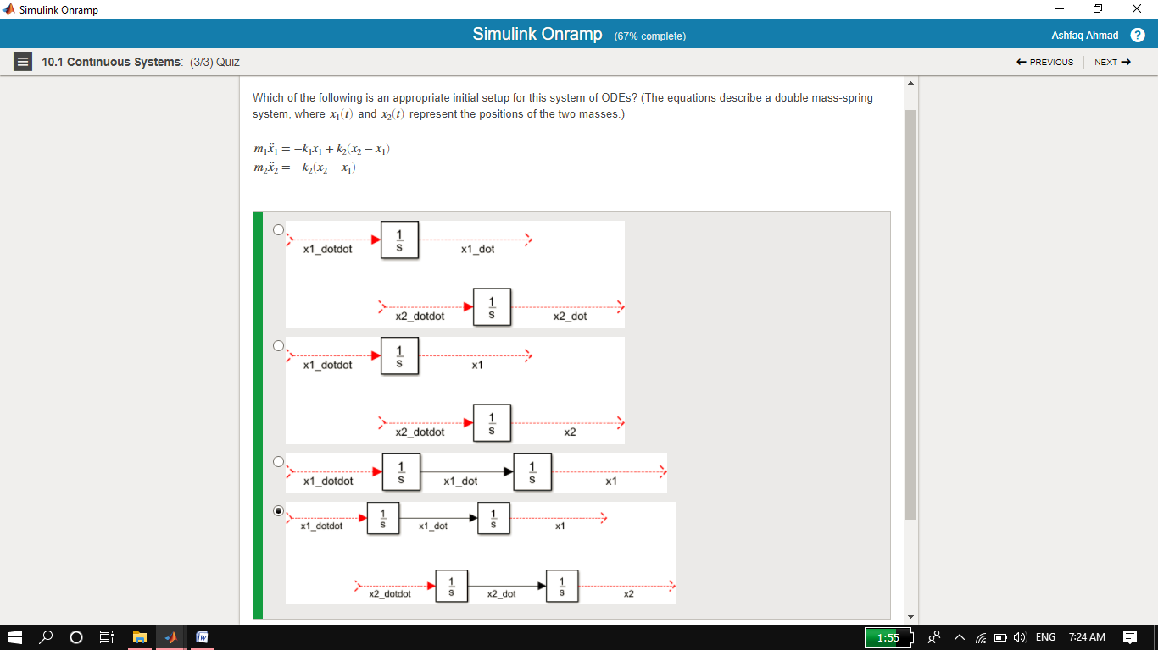

1. **Simulation Time**
   1. Choose the simulation duration.

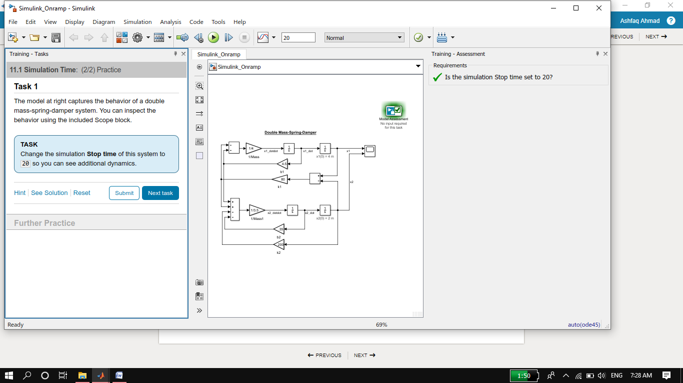

1. **Project- Modeling a Thermostat**
   1. Practice your understanding of discrete dynamic systems.

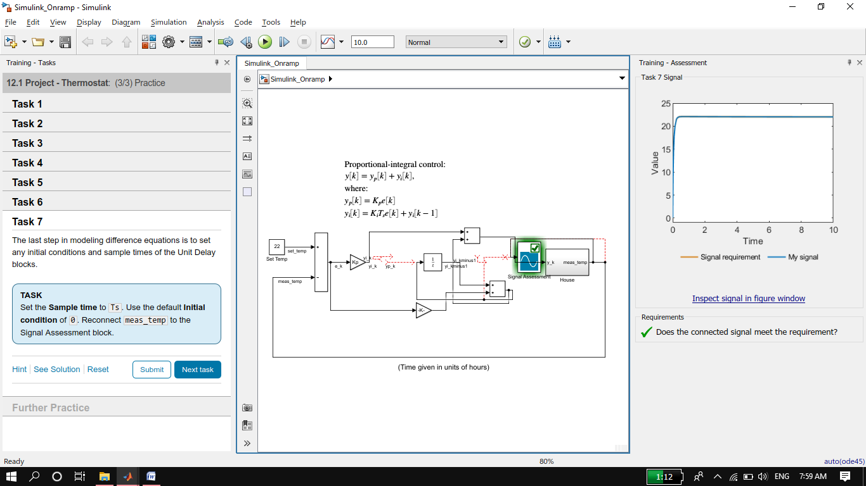

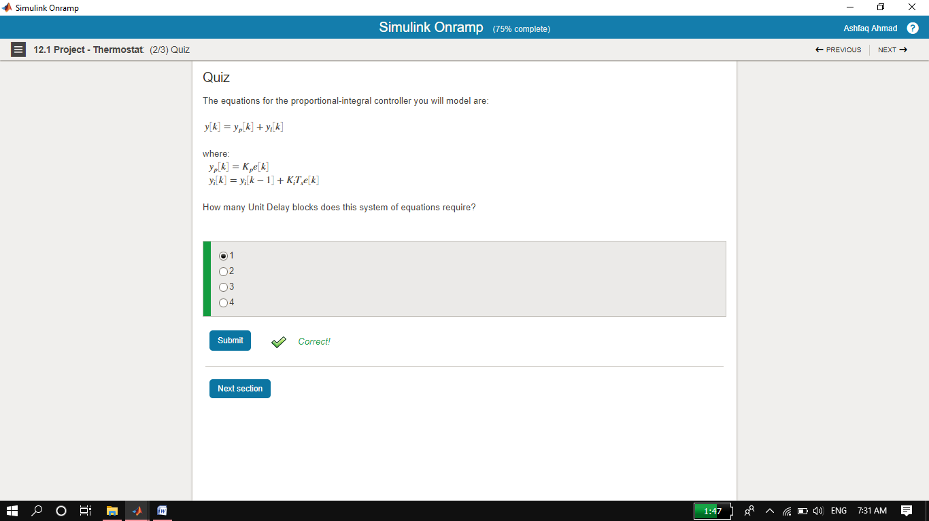

1. **Project – Peregrine Falcon Dive**
   1. Practice your understanding of continous dynamic systems.

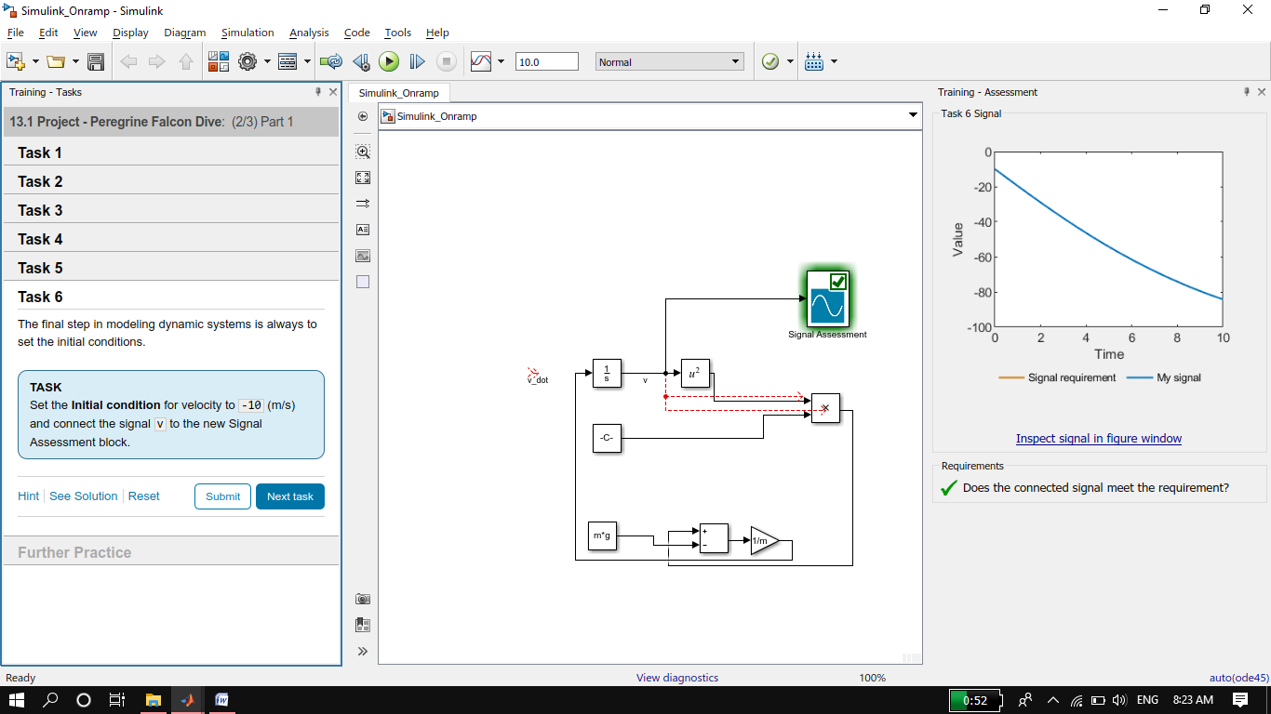

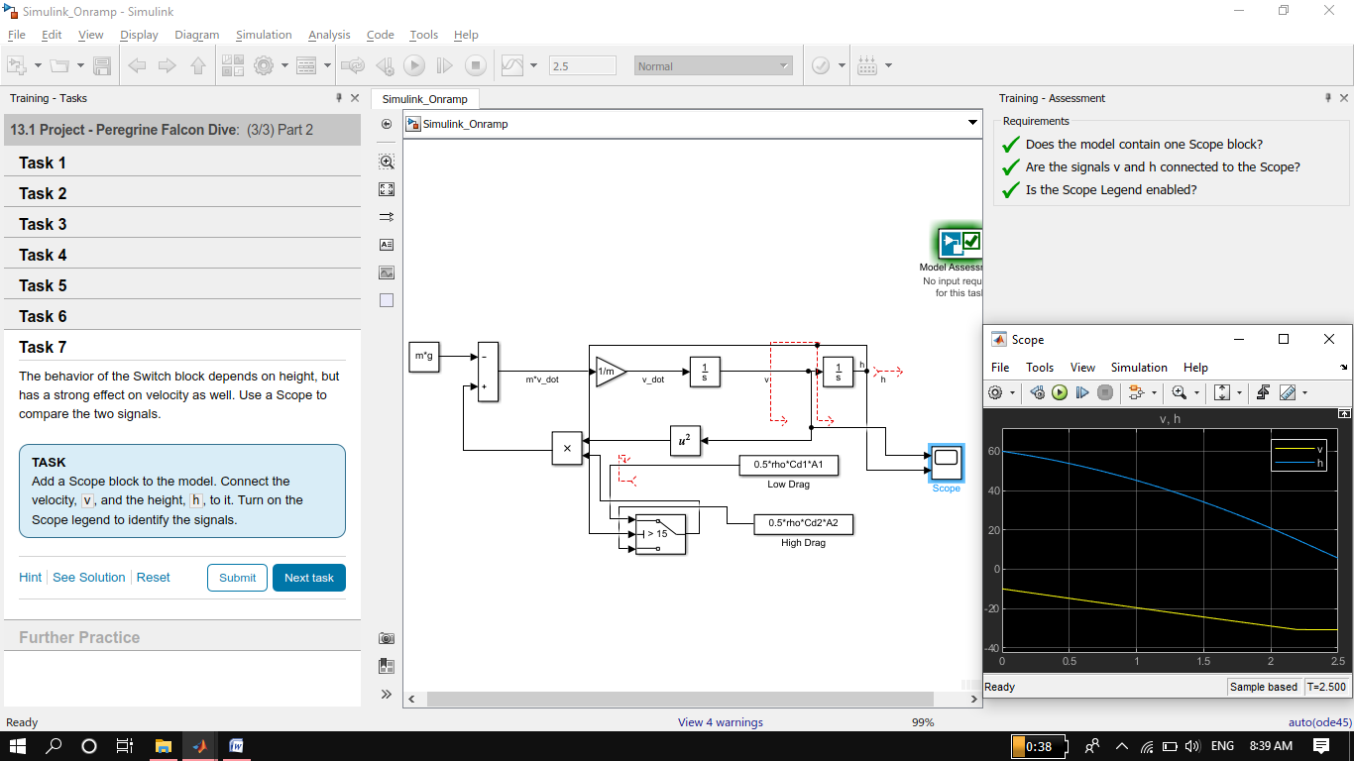

1. **Conclusions**

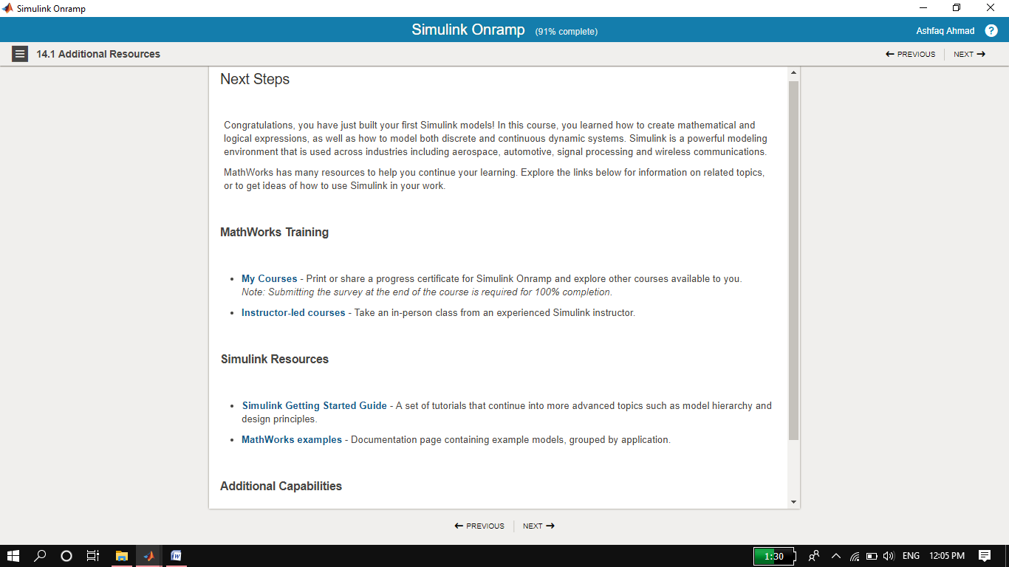

**Certificate:**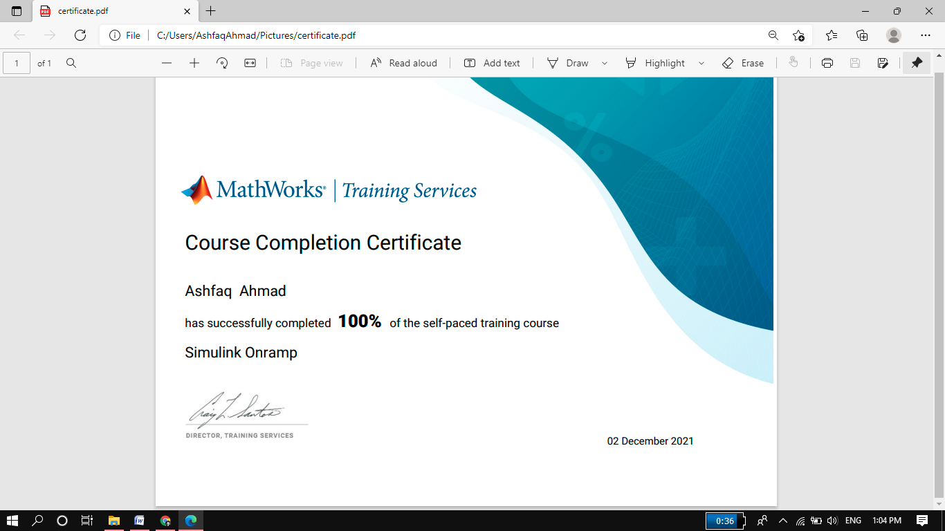

# THE END